**Directory Introduction**

**1.mkdir**

Mkdir is used to create a new directory

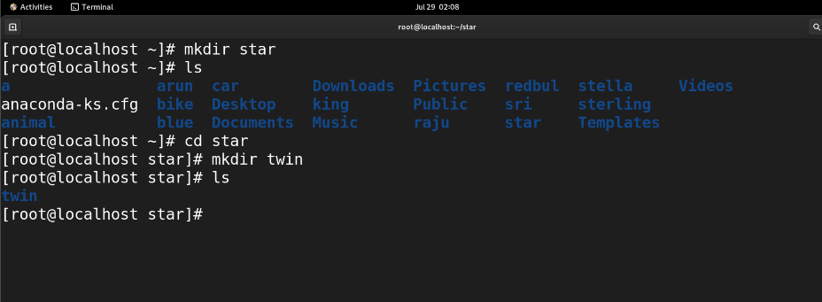

**2.mkdir -p**

mkdir -p is used to create three directory in a row

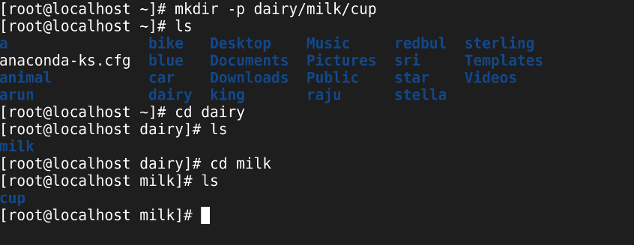

**3.Change Directory**

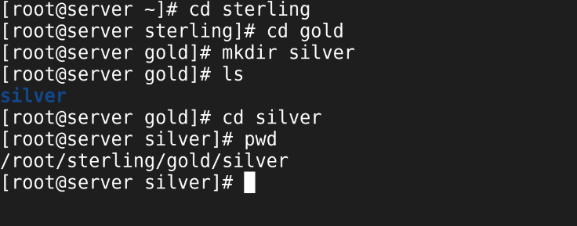

**4.Relative path :**

 Relative path is a path to a file or directory that is relative to the current directory**.**

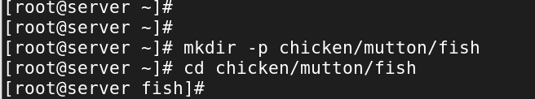

**5.Absolute path :**

  location of a file or directory specified from the root directory

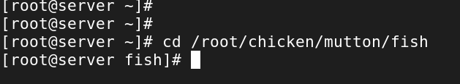

**6.Remove directory :**

* rmdir to remove the empty directory.

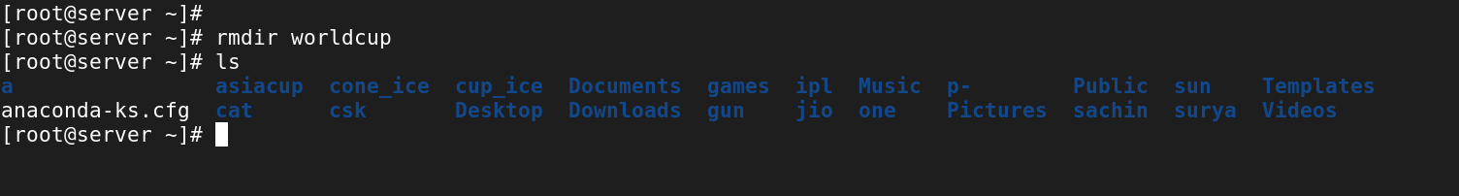

* rm -r is a regressive removal.

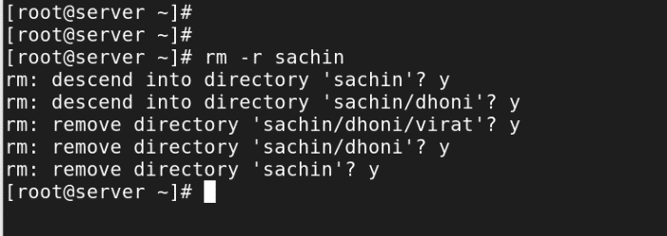

* rm -rf is use to remove forcefully

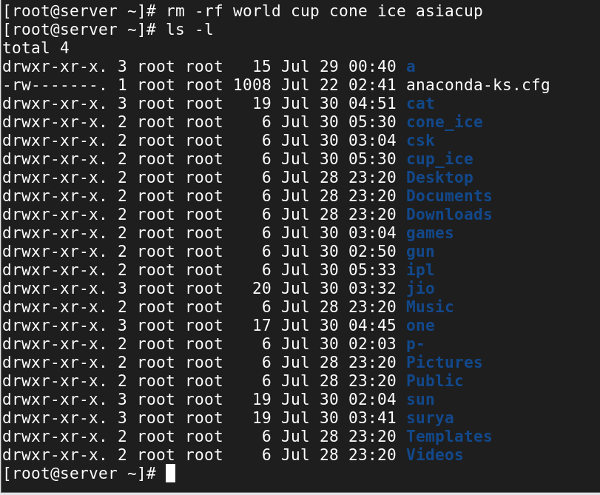

**7.Touch :**

 used to create a new empty file and to change the timestamps of existing files.

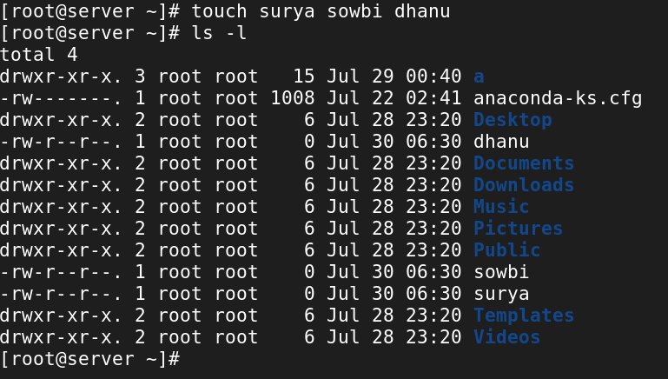

**8.Multiple Directories :**

It is used to create more or multiple directory

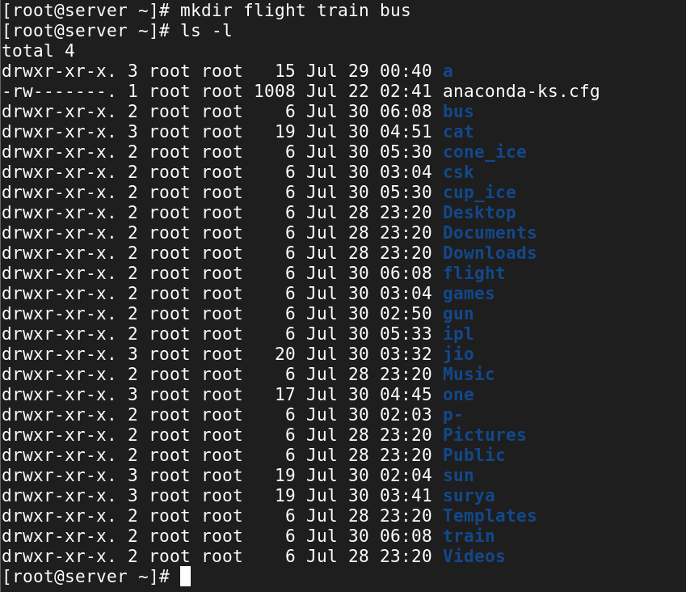

**9.Remove file :**

rm -f(directory)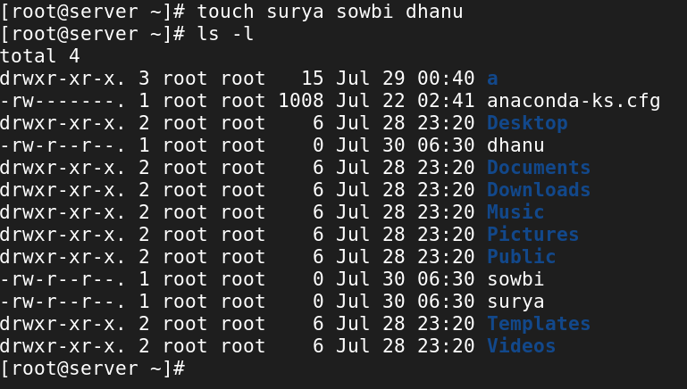

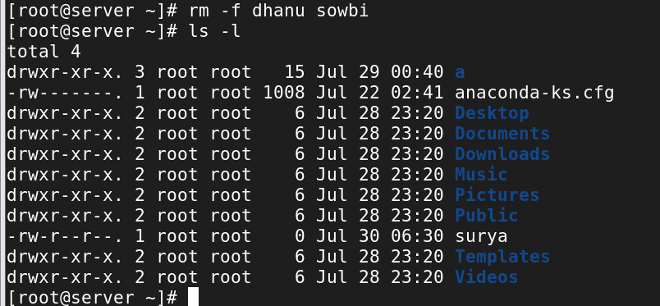

**10. How to change host name ?** 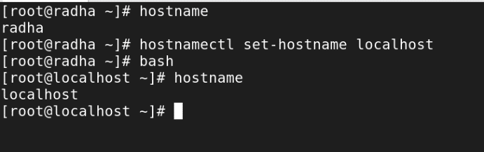

**11. CAT**

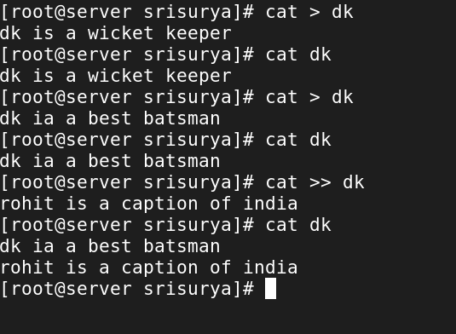

**12. Copy**

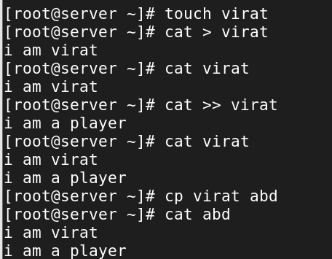

**13. Grep :**

It is used to search particular word

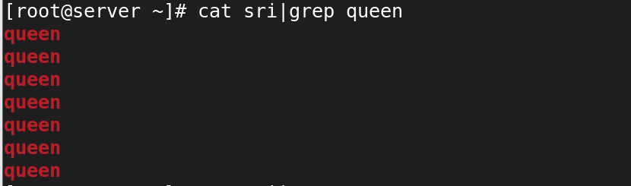

-n is used to view the number of lines

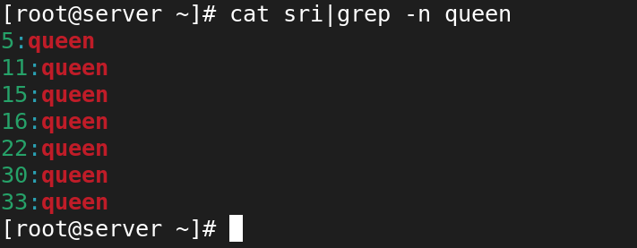

**14. Fallocate :**

It is used to allocate the file size

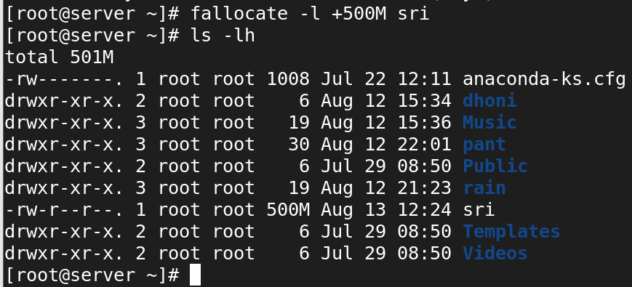

**15. Move :**

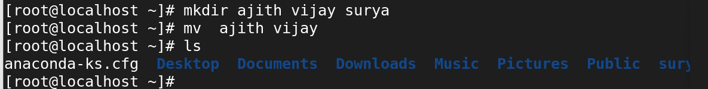

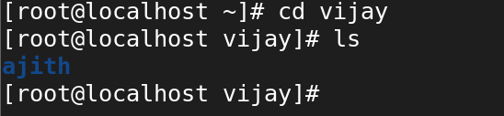

**16. cp : copy**

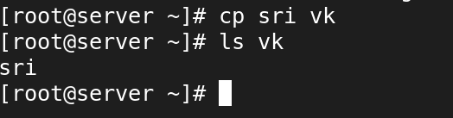

**17. cp -r :**

coping one directory to another directory

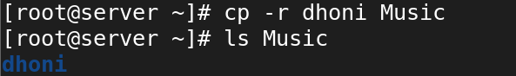

**18. Verbose :**

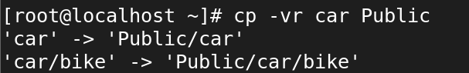

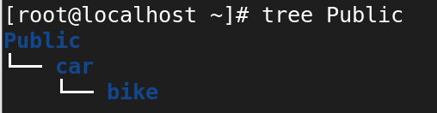

**19. Rename :**



**20. List :**

ls 🡺 list

ls -l 🡺 long list

ls -i 🡺 i node number

ls -la 🡺 show hidden files

ls -ld 🡺 view particular directory

ls -la 🡺 view hidden files

ls -ltr 🡺 reserve time

ls -lt 🡺 To view time in normal list

ls -lR 🡺 To view tree structure

**19. VI Editor :**

Vi Editor is used to create a filename

**20. Modes**

Command mode 🡺 press ESC

Insert mode 🡺 press i,I,A

yy 🡺 copy a line

3yy 🡺 copy 3 line

P 🡺 past copy line

dd 🡺 to delete a line

4dd 🡺 to delete 4 lines

/word 🡺 to search any key word

n 🡺 next search

N 🡺 previous search

u 🡺 undo

ctrl + r 🡺 redo

h 🡺 move to left

j 🡺 move to down

k 🡺 move to top

l 🡺 move to right

I 🡺 insert the text

I 🡺 insert the text in beginning

a 🡺 adds the text after the current cursor

A 🡺 adds the text at the end of a line

:q 🡺 without saving quite from file

:q! 🡺 forcefully quite

:w 🡺 save the changes

:w! 🡺 forcefully save chang

:wq 🡺 save and quite

:wq! 🡺 forcefully save and quite

:x 🡺 save and quite

:25 🡺 moves cursor to 25th line

:set nu 🡺 to set line numbers to line in the file

:set nonu - remove line numbers

:5d - delete 5th line

:$d - delete last line

**21.** search a word and replace it with new word

:%s/old/new/g

**22.** Without opening a file and find and replace a word

# sed -e “s/old/new/g” filename